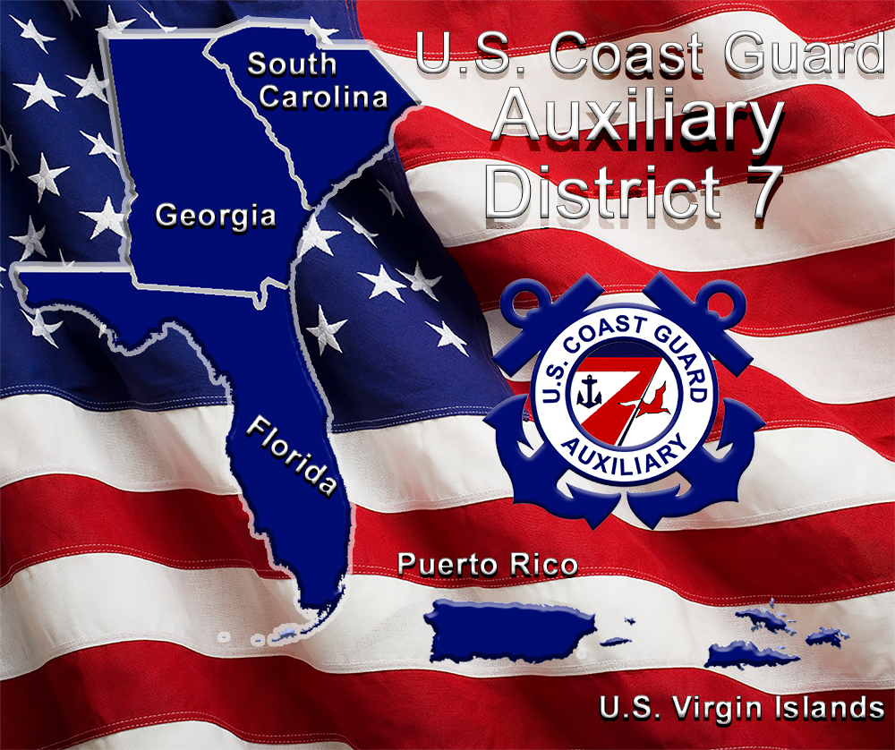

Seventh District Coast Guard Auxiliary
Form FN-1: Reimbursement for Mission and Activity Expenses

PRIOR AUTHORIZATION REQUIRED FOR REIMBURSEMENT

Date:
Name:
Address:
City/State/Zip:
Home Phone:
e-mail address:

Reason for Reimbursement:

TYPE OF EXPENSE | DATE | AMOUNT |  | TRAVEL DATE | START LOCATION  END LOCATION | MILES

NOTES:
Required Receipts:
Lodging and pre-approved expenses greater than $75.00.

Reimbursements Greater Than $75.00:
Send FN-1 and receipts, by email or mail, to DSO-FN within 30 days. Send copy of FN-1 to DCO.

Reimbursements for $75.00 and Under:
Send FN-1 by email or mail to DSO-FN.

Per Diem:
$40.00 per full day; $20.00 each travel day.

Mileage:
Current Auxiliary rate. (as of January 2023 amount is $0.60 per mile)

Do Not Total:
The DSO-FN calculates per diem and mileage allowance.

Email and Mailing Addresses:
Donna Miller, D7 DSO-FN COMO John Holmes
193 Bahama Blvd. john.holmes@cgaauxnet.us
Cocoa Beach, FL 32931-3206
donnaleemiller@yahoo.com
Revised: 1 January, 2023

